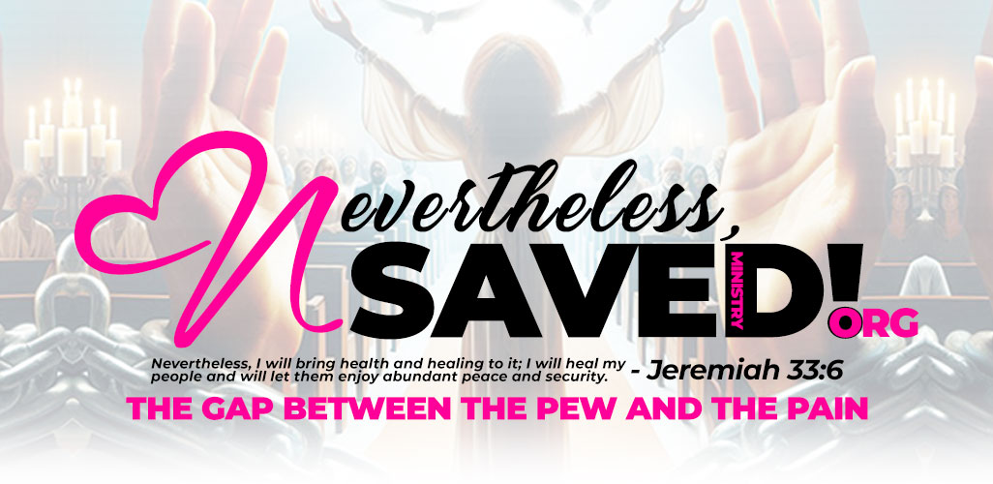

NeverthelessSAVED 7-Day Devotional Series
“Dear Sister…” A Journey for the Broken, the Brave, the Believer, and the One Just Barely Holding On

Day 1: Dear Sister Who's Tired
Scripture: Matthew 11:28 - "Come to Me, all who are weary and burdened, and I will give you rest."
You don’t need to be perfect to be loved. You don’t need to keep performing. Rest is not weakness—it’s worship. Breathe. You are treasured.

Journal Reflection
What stood out to me today? __________________________
What am I surrendering today? ________________________
My prayer: __________________________________________
____________________________________________________
____________________________________________________

Day 2: Dear Sister Who Feels Forgotten
Scripture: Isaiah 49:15-16 - "I will not forget you. See, I have written your name on the palms of My hands."
You are not invisible to God. When everyone else walks away, He leans in. You are remembered, held, and still chosen.

Journal Reflection
What stood out to me today? __________________________
What am I surrendering today? ________________________
My prayer: __________________________________________
____________________________________________________
____________________________________________________

Day 3: Dear Sister Still Carrying Shame
Scripture: Psalm 34:5 - "Those who look to Him are radiant; their faces are never covered with shame."
You are not what you did. Your identity is not your past. Shame says hide—grace says come. You are forgiven.

Journal Reflection
What stood out to me today? __________________________
What am I surrendering today? ________________________
My prayer: __________________________________________
____________________________________________________
____________________________________________________

Day 4: Dear Sister Who Wants to Give Up
Scripture: Psalm 27:13 - "I would have lost heart, unless I had believed..."
Even now, you are being held. You’re not too far gone. If you're still here, you still have purpose.

Journal Reflection
What stood out to me today? __________________________
What am I surrendering today? ________________________
My prayer: __________________________________________
____________________________________________________
____________________________________________________

Day 5: Dear Sister Who Feels Like a Failure
Scripture: Psalm 145:14 - "The Lord upholds all who fall..."
Failure is an event, not your identity. God doesn’t abandon the fallen—He lifts them. You are still becoming.

Journal Reflection
What stood out to me today? __________________________
What am I surrendering today? ________________________
My prayer: __________________________________________
____________________________________________________
____________________________________________________

Day 6: Dear Sister Who Is Ready to Heal
Scripture: Psalm 147:3 - "He heals the brokenhearted..."
Healing doesn’t mean forgetting—it means freedom. God is not afraid of your wounds. He wants to restore them.

Journal Reflection
What stood out to me today? __________________________
What am I surrendering today? ________________________
My prayer: __________________________________________
____________________________________________________
____________________________________________________

Day 7: Dear Sister Who Knows She's Still Here for a Reason
Scripture: Romans 8:28 - "All things work together for good..."
Your survival is proof. God didn’t let you die in that thing for no reason. He’s not finished with you yet.

Journal Reflection
What stood out to me today? __________________________
What am I surrendering today? ________________________
My prayer: __________________________________________
____________________________________________________
____________________________________________________

